Homework 5

Chang 6: Multicategory Logit Model

Problem 4: 6.3

Problem 5: 6.7

Problem 6: 6.11

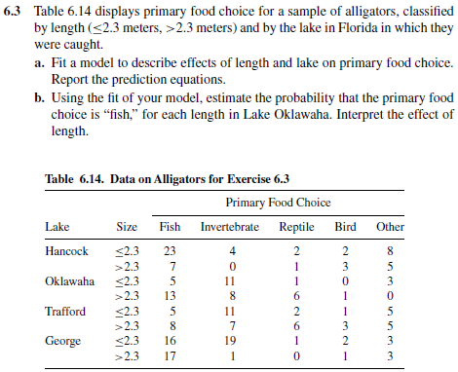

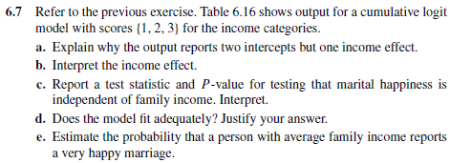

**Table 6.16 see next page**

